University of Hertfordshire
School of Physics, Engineering and Computer Science

Interim Progress Report (IPR)

Detection of Invasive Ductal Carcinoma (IDC) in Breast Histopathology Images:
A Comparative Study of a Custom CNN and Transfer-Learning Architectures for Privacy-Aware Clinical Decision Support

Module: | 7COM1039 – MSc Project (Cyber Security)
Student Name: | Khadija Ibrahim
Student Number: | 24143032
Supervisor: | Sydney Ezika

Submitted: July 2026
Word count (excluding cover page, references and appendices): approx. 4,300

Table of Contents
1. Background Research and Literature Review
1.1 Project Introduction, Goals and Objectives
1.2 Research Question and Sub-Questions
1.3 Critical Review of Relevant Literature
1.4 From Theory to Practice
2. Summary of Progress to Date
2.1 Completed Work Mapped to Project Milestones
2.2 Tools and Technologies (and Justification)
2.3 Deliverables and Evidence
2.4 Comparative Results
2.5 Challenges Encountered and How They Were Handled
3. Consideration of Ethical, Legal, Professional and Social Issues
4. Project Plan
5. Level of the Project
6. References
7. Appendices

1. Background Research and Literature Review

1.1 Project Introduction, Goals and Objectives
Breast cancer remains one of the most significant global health burdens. The World Health Organization (WHO, 2023) reported approximately 2.3 million new diagnoses and 685,000 deaths in 2020 alone, with Invasive Ductal Carcinoma (IDC) representing the most common subtype. The diagnostic gold standard is the histopathological examination of stained tissue biopsies under a microscope. This manual workflow is time-consuming, subjective, and prone to inter-observer variability, meaning that diagnostic accuracy can depend heavily on an individual pathologist’s experience (Nassif et al., 2022). These limitations motivate the development of automated, reproducible decision-support tools that can act as a reliable “second opinion” for clinicians.
This project investigates the automated detection of IDC in digitised breast histopathology image patches using deep learning. Because the project is undertaken within an MSc Cyber Security programme, it deliberately couples the machine-learning investigation with an analysis of the data-protection and security implications of deploying such a model on sensitive clinical data. The central practical contribution completed at this interim stage is a controlled comparative evaluation of four convolutional architectures – a purpose-built lightweight network (referred to here as IDCNet) and three established transfer-learning backbones (ResNet50, VGG19 and EfficientNetB0) – trained and tested under identical conditions.
Goal.
To design, train and comparatively evaluate deep-learning models that can classify breast histopathology image patches as IDC-positive or IDC-negative with high accuracy and clinically acceptable sensitivity, and to establish, on that evidence, a privacy-aware pathway for deploying the strongest model as a decision-support tool.
Objectives (specific and measurable).
- O1 – Data: acquire the public Breast Histopathology Images dataset and construct a cleaned, class-balanced corpus of 50×50 RGB patches suitable for supervised training.
- O2 – Baseline model: design and train a custom, parameter-efficient CNN baseline (IDCNet) for binary IDC classification.
- O3 – Comparative models: implement three transfer-learning models (ResNet50, VGG19, EfficientNetB0) under identical pre-processing, optimisation and augmentation settings to enable a fair comparison.
- O4 – Evaluation: evaluate every model with accuracy, confusion matrix, class-wise recall (sensitivity/specificity) and ROC-AUC on a held-out test set.
- O5 – Analysis: critically analyse the accuracy–sensitivity trade-off across architectures and interpret its clinical and security significance.
- O6 – Secure delivery: (next phase) package the selected model behind a secure, privacy-preserving inference interface and document its data-protection posture.

1.2 Research Question and Sub-Questions
The project has narrowed from the broad “build an end-to-end diagnostic system” framing of the Detailed Project Proposal (DPP) (Ibrahim, 2026) towards a focused, evidence-driven investigation:
Main research question: To what extent can convolutional deep-learning models accurately detect Invasive Ductal Carcinoma in breast histopathology patches, and how does a lightweight custom CNN compare with established transfer-learning architectures in the trade-off between overall accuracy and diagnostic sensitivity?
Sub-questions:
- Does a small purpose-built CNN outperform larger pre-trained backbones on 50×50 patch data, and why?
- How does class balancing affect the sensitivity (IDC-positive recall) of each architecture?
- What are the data-protection and security considerations of deploying the strongest model on sensitive histopathology data, and how can cloud-transmission risk be reduced?

1.3 Critical Review of Relevant Literature
Rather than surveying the field exhaustively, four sources were engaged critically because they directly shaped the methodological decisions taken in this project.
Transfer learning versus training from scratch.
Mahmud et al. (2023) present a systematic analysis of transfer-learning backbones (including ResNet and VGG variants) for breast-cancer histopathology and report that ImageNet-pre-trained networks converge quickly and reach strong accuracy on tissue-patch classification. Adam et al. (2023) reach broadly similar conclusions for breast-image analysis. However, both are dominated by natural-image feature reuse, and neither foregrounds the mismatch between ImageNet’s object-centric features and the fine-grained textural cues of H&E-stained tissue. This tension motivated the decision in this project not to assume transfer learning is automatically superior, but to test a compact CNN trained from scratch against three pre-trained backbones under identical conditions. The empirical result (Section 2.4) supports this scepticism: the custom network outperformed all three transfer-learning models on this low-resolution patch task.
The shift to foundation and explainable models.
A landmark multi-centre study in The Lancet Oncology (Shamai et al., 2026) demonstrated that deep models can predict molecular recurrence risk directly from routine H&E slides, signalling a shift from simple patch classification towards whole-slide foundation models. In parallel, the WEEP region-selection method (Sharma, 2026) and morphologically-guided, interpretable pipelines (MDPI Applied Sciences, 2025) address the “black-box” objection that impedes clinical adoption. These works are aspirational relative to the scope achievable in a single MSc project, but they usefully frame the limitations of a pure patch-classifier: it produces a decision without a verifiable spatial rationale. This directly informs the planned next phase (region-attribution overlays) and the honest positioning of the current artefact as a baseline rather than a finished clinical system.
Contrasting viewpoints.
The literature therefore contains a productive tension: the classical CNN/transfer-learning camp (Mahmud et al., 2023) prioritises accessible, patch-level accuracy, while the foundation-model camp (Shamai et al., 2026) prioritises whole-slide context and interpretability at much higher computational cost. This project positions itself deliberately in the first camp for the interim artefact – lightweight, reproducible, deployable on modest hardware – while drawing on the second camp’s emphasis on interpretability and privacy to shape the evaluation criteria and the future work. The privacy dimension is where the MSc Cyber Security framing adds a distinct angle that neither camp treats as central.

1.4 From Theory to Practice
The literature translated into concrete engineering decisions. First, the reported sensitivity of medical classifiers to class imbalance (Buda, Maki and Mazurowski, 2018) motivated explicit sub-sampling of the majority IDC-negative class to parity with the IDC-positive class before training, rather than training on the raw, heavily skewed distribution. Second, the standard transfer-learning recipe from Mahmud et al. (2023) – frozen ImageNet base plus a small trainable classification head – was replicated identically across ResNet50, VGG19 and EfficientNetB0 so that architecture, not tuning effort, is the variable under study. Third, the interpretability concerns raised by Sharma (2026) shaped the evaluation: models were judged not only on headline accuracy but on class-wise recall and ROC-AUC, because a false negative in this domain (a missed cancer) carries far greater cost than a false positive.

2. Summary of Progress to Date
At this interim point the data pipeline and the entire comparative modelling phase are complete. This corresponds to Milestones 2–4 of the DPP being finished, with Milestones 5–8 (secure delivery, system testing, formal validation and packaging) forming the remaining work. Approximately 290 hours have been invested to date, concentrated on dataset engineering, iterative model development, and the comparative evaluation reported below. Evidence for every claim in this section is provided as annotated notebook screenshots in the Appendices.

2.1 Completed Work Mapped to Project Milestones
Milestone 2 – Data collection and pre-processing (complete).
The Breast Histopathology Images dataset (Mooney, no date; originally curated by Cruz-Roa et al., 2014 and Janowczyk and Madabhushi, 2016) was acquired programmatically through the Kaggle API inside Google Colab. The dataset contains roughly 277,000 50×50-pixel RGB patches labelled IDC-negative (class 0) or IDC-positive (class 1). Because the raw data is heavily imbalanced towards IDC-negative patches, the majority class was sub-sampled so that both classes were represented by 12,389 patches, giving a balanced corpus of 24,778 patches. Images were read and resized with OpenCV, pixel values normalised to the 0–1 range, and the corpus split 70/30 into training and test partitions using scikit-learn. On-the-fly data augmentation (random rotation up to 20°, width/height shifts, shear, zoom and horizontal/vertical flips) was applied during training via Keras’ ImageDataGenerator to improve generalisation. (See Appendix A for the acquisition, balancing and pre-processing code.)
Milestones 3 and 4 – Algorithm development and model training (complete).
Four architectures were implemented and trained end-to-end for 200 epochs each with the Adam optimiser (learning rate 0.0001), binary cross-entropy loss and a batch size of 35:
- IDCNet: a custom sequential CNN (IDCNet) with three convolutional blocks (32, 64 and 128 filters, each with batch normalisation, 2×2 max-pooling and dropout), followed by a 128-unit dense layer and a sigmoid output – approximately 684,700 trainable parameters;
- ResNet50, VGG19 and EfficientNetB0: each with the ImageNet-pre-trained convolutional base frozen and an identical trainable classification head (global average pooling → dense → dropout → sigmoid) attached on top.
Training and validation accuracy/loss curves were logged for every model and are reproduced in the Appendices as evidence of convergence.

2.2 Tools and Technologies (and Justification)
Tool / technology | Role in the project | Why it was chosen
Python 3 | Primary implementation language | De-facto standard for machine learning with mature scientific libraries
TensorFlow / Keras | Model definition, training, evaluation | High-level API for rapid, reproducible CNN and transfer-learning development
Google Colab (GPU) | Training environment | Free GPU acceleration; removed the need for local high-cost hardware
scikit-learn | Train/test split and metrics | Reliable, well-tested implementations of splitting and confusion-matrix / ROC metrics
OpenCV | Image I/O and resizing | Efficient handling of hundreds of thousands of image patches
NumPy / pandas | Array and data handling | Vectorised numerical operations underpinning the pipeline
Matplotlib / seaborn | Visualisation of curves and confusion matrices | Clear, publication-quality evaluation figures
Kaggle API | Dataset acquisition | Reproducible, scriptable download of the benchmark dataset

This stack was chosen for reproducibility and cost-efficiency: the entire pipeline runs on free Colab GPUs, directly addressing the DPP’s stated concern about the prohibitive hardware costs of modern foundation models in resource-limited settings.

2.3 Deliverables and Evidence
- A reproducible data-acquisition, balancing and pre-processing pipeline (Appendix A).
- Four trained Keras models saved as .h5 artefacts (Brest_idc_Model2.h5, Brest_idc_resnet.h5, Brest_idc_VGG19_Model.h5, Brest_idc_eff_Model.h5).
- A comparative evaluation suite producing accuracy scores, confusion matrices (absolute and percentage), and a ROC curve for the baseline model (Appendices A–D).
- A working single-image inference routine that loads a saved model and classifies uploaded patches as IDC(+) / IDC(−) (Appendix A).

2.4 Comparative Results
All four models were evaluated on their held-out test partitions. The headline finding is that the compact custom CNN clearly outperformed all three transfer-learning backbones, both on overall accuracy and – more importantly for this clinical task – on sensitivity (IDC-positive recall).
Model | Test accuracy | Specificity (IDC− recall) | Sensitivity (IDC+ recall) | ROC-AUC
IDCNet (custom CNN) | 96.74% | 98.9% | 84.8% | 0.98
VGG19 (transfer) | 89.97% | 92.9% | 73.5% | –
EfficientNetB0 (transfer) | 89.86% | 92.8% | 73.1% | –
ResNet50 (transfer) | 89.67% | 95.3% | 58.4% | –

The confusion matrices make the trade-off concrete. IDCNet produced 6,210 true negatives, 66 false positives, 176 false negatives and 982 true positives – i.e. it correctly ruled out 98.9% of benign patches while still recovering 84.8% of cancerous patches, with a ROC-AUC of 0.98. ResNet50, by contrast, achieved comparable specificity (95.3%) but its sensitivity collapsed to 58.4% (473 false negatives against 663 true positives), meaning it missed roughly four in ten cancerous patches. VGG19 and EfficientNetB0 sat between these extremes with sensitivities of 73.5% and 73.1% respectively.
Note on the “98.9” figure.
It is important to be precise: the 98.9% associated with the baseline model is its specificity (the percentage of IDC-negative patches correctly identified), not its overall accuracy. The overall test accuracy of IDCNet is 96.74%. This distinction is maintained throughout the report to avoid overstating performance.

2.5 Challenges Encountered and How They Were Handled
- Class imbalance. The raw dataset is dominated by IDC-negative patches. Training on it directly biases models toward the majority class and inflates accuracy while hiding poor sensitivity. This was mitigated by sub-sampling the negative class to parity before training; even so, the transfer-learning models retained a visible sensitivity deficit, which is itself a reportable finding.
- Over-fitting. IDCNet’s training accuracy approaches 99% while validation accuracy plateaus around 96–97%, a mild over-fitting signal. Dropout, batch normalisation and aggressive augmentation were used to contain it; monitoring the validation curve (Appendix A) confirmed the gap remained modest and stable rather than diverging.
- Compute limits. Long 200-epoch training runs on free Colab GPUs risked session timeouts. Models were checkpointed and saved to Google Drive as .h5 files so that runs could be resumed and results preserved.
- Scope/methodology reconciliation. The DPP proposed a 60/20/20 train/validation/test split, whereas the implemented notebooks use a 70/30 train/test split with the test set doubling as the validation monitor. This is acknowledged as a deviation; a dedicated three-way split will be reinstated for the final formal validation (Milestone 7) to avoid any optimistic bias from monitoring on the test set.

3. Consideration of Ethical, Legal, Professional and Social Issues
Whether formal ethics approval is required is the first question. This project uses only a publicly available, de-identified secondary dataset (Mooney, no date; Cruz-Roa et al., 2014; Janowczyk and Madabhushi, 2016). No patients are recruited, no primary data is collected, and no identifiable personal information is processed. Under the University of Hertfordshire’s research-ethics framework, secondary analysis of fully anonymised, public data of this kind typically falls outside the scope requiring full ethical review; however, this position has been recorded for confirmation with the supervisor rather than assumed, and any change of scope (for example, acquiring slides from a clinical partner) would trigger a fresh ethics assessment.
Legal.
Even though the patches are de-identified, the General Data Protection Regulation (GDPR) remains relevant in principle because health data is a special category and re-identification risk can never be assumed to be zero once data is combined or a model is deployed. The project therefore treats data-minimisation and purpose-limitation as design constraints. The dataset’s licensing and citation terms are respected, and the intellectual-property position of reusing the author’s own earlier DPP and IPR text is handled by explicit self-citation (Ibrahim, 2026), consistent with the assignment’s reuse guidance.
Professional.
The work follows the BCS Code of Conduct and IEEE ethical-practice expectations regarding competence, honest reporting of results and public interest. Concretely, this means reporting the sensitivity limitations of the models openly rather than headlining only the best accuracy figure, and positioning the artefact strictly as a decision-support “second opinion” rather than an autonomous diagnostic device. Should the tool ever move toward clinical use, it would fall under medical-device software regulation (e.g. MHRA/UK and FDA guidance on AI as a medical device), which is noted as a future compliance obligation.
Social.
The most significant social risk is biased generalisation: a model trained on one dataset’s staining and scanner characteristics may under-perform on tissue from other sites, potentially disadvantaging patients whose samples differ from the training distribution – a concern the DPP itself flagged as a market limitation. Conversely, a lightweight model that runs on modest hardware could improve access to screening support in resource-limited clinics, an equity benefit. Both effects would intensify if the project is developed into a deployed system.
Evolution with the MSc Cyber Security angle.
As the project moves toward deployment, the security dimension becomes central. Transmitting high-resolution histopathology data to a cloud service introduces data-in-transit exposure; a deployed model is also vulnerable to model-inversion and membership-inference attacks that could, in principle, leak information about training data, and to adversarial perturbations that could flip a diagnosis. These risks directly justify the DPP’s emphasis on local/edge inference to avoid cloud transmission, and they define concrete security-testing objectives for the next phase (adversarial-robustness testing and a data-protection impact analysis). This is where the cyber-security framing adds genuine academic value beyond a purely accuracy-focused study.

4. Project Plan
The project follows a hybrid management approach: an overall waterfall milestone structure (inherited from the DPP) provides the backbone and fixed academic deadlines, while the modelling work within each milestone is run in short iterative cycles (design → train → evaluate → refine). Scope is managed by prioritising the comparative evaluation – which is now complete and de-risks the core contribution – ahead of the more exploratory secure-delivery work. Risk is handled by keeping the strongest trained model (IDCNet) as a stable, saved artefact so that later phases cannot jeopardise the demonstrable results already achieved. Quality is assured through consistent evaluation metrics across all models, weekly supervisor check-ins with Sydney Ezika, and version-controlled notebooks. Time is explicitly reserved at the end for writing the Final Report and preparing the demonstration.
Remaining tasks, deliverables and target dates.
Task | Status | Deliverable | Target
M1–M2 Initiation, data acquisition & pre-processing | Complete | Balanced 50×50 patch corpus + pipeline | Done
M3–M4 Model development & training (4 architectures) | Complete | Four trained, saved models | Done
M4b Comparative evaluation | Complete | Accuracy, confusion matrices, ROC-AUC | Done
M7a Formal validation (3-way split, sensitivity/specificity) | In progress | Statistically reported metrics | late Jul 2026
M5 Secure inference interface (privacy-aware web app) | Planned | Working demo + threat model | Aug 2026
M6 System & security testing (incl. adversarial robustness) | Planned | Test log + DPIA-style analysis | Aug 2026
M8 Documentation & packaging (containerisation) | Planned | Setup guide + container | early Sep 2026
Final Report writing & demonstration prep | Planned | Final Project Report | Sep 2026

Quality of the findings will be assessed against the evaluation criteria already established (class-wise recall and ROC-AUC, not accuracy alone), and the overall process will be reviewed against the milestone schedule at each supervisor meeting. A simple visual timeline of this plan is provided in Appendix E; exact final-submission dates will be confirmed against the module handbook. The plan retains deliberate slack in August to absorb the exploratory risk in the secure-delivery and security-testing tasks.

5. Level of the Project
This section reflects critically on why the project constitutes a valid MSc-level undertaking, drawing the report’s threads together across the artefact, the investigation and the methods.
The challenge and its personal relevance.
Automated cancer detection sits at the intersection of machine learning, medical imaging and – for a deployed system – data security, which is precisely the intersection that motivates my MSc Cyber Security studies and my intended career in securing AI systems for regulated, high-stakes domains. The problem is genuinely hard: the cost of a false negative is a missed cancer, so headline accuracy is an inadequate success measure, and this reframes the whole investigation around sensitivity and trustworthiness.
The artefact and its level.
The artefact is not a single tutorial model but a controlled comparative study of four architectures trained under identical conditions, plus the saved models and inference pipeline. Critically, it produced a non-trivial, defensible empirical finding: a compact custom CNN (96.74% accuracy, 84.8% sensitivity, ROC-AUC 0.98) outperformed three standard ImageNet transfer-learning backbones, whose sensitivity ranged from 58.4% (ResNet50) to 73.5% (VGG19). This diverges from the common assumption that pre-trained backbones dominate, and it is explicable: object-centric ImageNet features transfer poorly to 50×50 H&E texture patches, whereas a small network learned task-specific features directly. Producing an original comparative result, rather than reproducing a known one, is a marker of MSc-level work.
Depth of investigation, testing and validation.
The investigation combines theory (the transfer-learning vs. from-scratch debate, class-imbalance theory, interpretability literature) with rigorous practical evaluation (confusion matrices, class-wise recall, ROC-AUC). Planned testing deliberately targets edge cases that matter clinically and for security: stain-colour and scanner variation (domain shift), blurred or artefact-laden patches, class imbalance at inference time, and adversarial perturbations designed to flip predictions. The next phase adds a formal three-way split to remove the test-set-as-validation bias identified in Section 2.5, strengthening the statistical validity of the reported sensitivity and specificity.
Justification of methods and tools.
Holding pre-processing, optimiser, augmentation and training budget constant across all four models is what makes the comparison fair and the conclusion attributable to architecture rather than tuning – an experimental-design choice appropriate to the research question. The tool stack (TensorFlow/Keras on Colab) was selected for reproducibility and for its alignment with the project’s goal of low-cost, deployable inference. Together these choices give the results their reliability and make the study repeatable, which is the standard expected at this level.

6. References
Adam, R., Dell’Aquila, K., Hodges, L., Maldjian, T. and Duong, T.Q. (2023) ‘Deep learning applications to breast cancer detection by magnetic resonance imaging’, Breast Cancer Research, 25(1).
Buda, M., Maki, A. and Mazurowski, M.A. (2018) ‘A systematic study of the class imbalance problem in convolutional neural networks’, Neural Networks, 106, pp. 249–259.
Cruz-Roa, A., Basavanhally, A., González, F., Gilmore, H., Feldman, M., Ganesan, S., Shih, N., Tomaszewski, J. and Madabhushi, A. (2014) ‘Automatic detection of invasive ductal carcinoma in whole slide images with convolutional neural networks’, Proc. SPIE Medical Imaging, 9041.
He, K., Zhang, X., Ren, S. and Sun, J. (2016) ‘Deep residual learning for image recognition’, Proceedings of the IEEE Conference on Computer Vision and Pattern Recognition (CVPR), pp. 770–778.
Ibrahim, K. (2026) Detection of Invasive Ductal Carcinoma (IDC): Detailed Project Proposal. Unpublished MSc project proposal, University of Hertfordshire.
Janowczyk, A. and Madabhushi, A. (2016) ‘Deep learning for digital pathology image analysis: a comprehensive tutorial with selected use cases’, Journal of Pathology Informatics, 7(1), p. 29.
Mahmud, M.I., Mamun, M. and Abdelgawad, A. (2023) ‘A deep analysis of transfer learning based breast cancer detection using histopathology images’, arXiv:2304.03212.
MDPI Applied Sciences (2025) ‘Enhancing AI-driven diagnosis of invasive ductal carcinoma with morphologically guided and interpretable deep learning’, Applied Sciences, 15(12), 6883.
Mooney, P. (no date) Breast Histopathology Images Dataset. Kaggle. Available at: https://www.kaggle.com/datasets/paultimothymooney/breast-histopathology-images (Accessed: July 2026).
Nassif, A.B., Talib, M.A., Nasir, Q., Afadar, Y. and Elgendy, O. (2022) ‘Breast cancer detection using artificial intelligence techniques: a systematic literature review’, Computer Methods and Programs in Biomedicine, 222, 106925.
Shamai, G., Cohen, S., Binenbaum, Y. et al. (2026) ‘Deep learning on histopathological images to predict breast cancer recurrence risk and chemotherapy benefit: a multicentre, model development and validation study’, The Lancet Oncology, 27(4).
Sharma, A. (2026) Novel deep learning-based models for cancer histopathology image analysis. Karolinska Institutet. Available at: https://news.ki.se/novel-deep-learning-based-models-for-cancer-histopathology-image-analysis (Accessed: July 2026).
Simonyan, K. and Zisserman, A. (2014) ‘Very deep convolutional networks for large-scale image recognition’, arXiv:1409.1556.
Tan, M. and Le, Q. (2019) ‘EfficientNet: rethinking model scaling for convolutional neural networks’, Proceedings of the 36th International Conference on Machine Learning (ICML), pp. 6105–6114.
World Health Organization (2023) Breast cancer fact sheet. Available at: https://www.who.int/news-room/fact-sheets/detail/breast-cancer (Accessed: July 2026).

7. Appendices
The appendices provide supporting evidence for the progress reported in Section 2, in the form of annotated screenshots taken directly from the project’s Google Colab notebooks. Each figure is referenced from the relevant point in the main report.

Appendix A – IDCNet (custom CNN): pipeline, training and evaluation
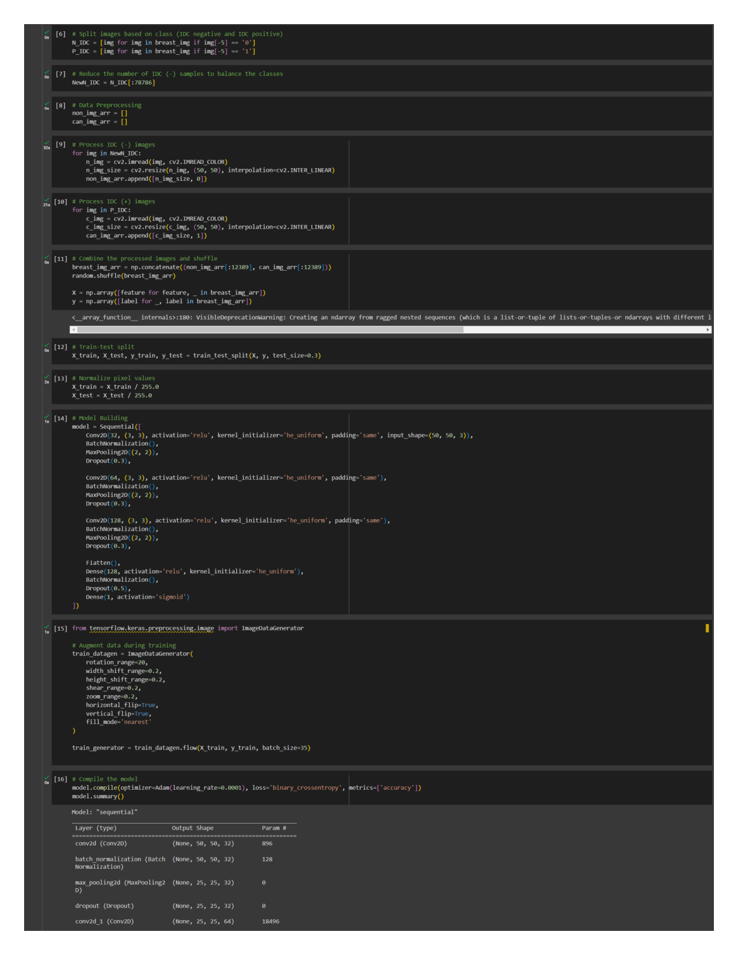
Figure A1. Class splitting, majority-class balancing (12,389 patches per class), 70/30 train/test split, normalisation and the IDCNet architecture definition.
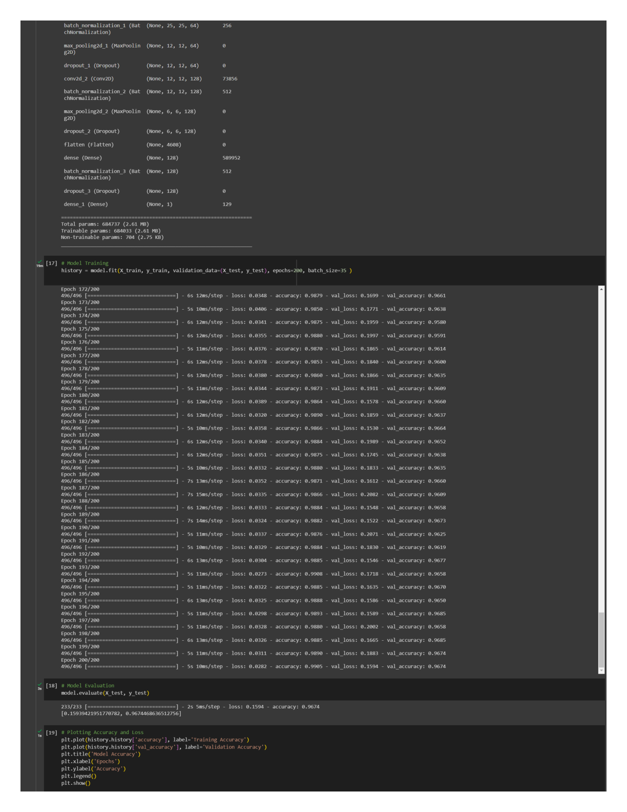
Figure A2. Model summary (≈684,700 trainable parameters) and training log across 200 epochs.
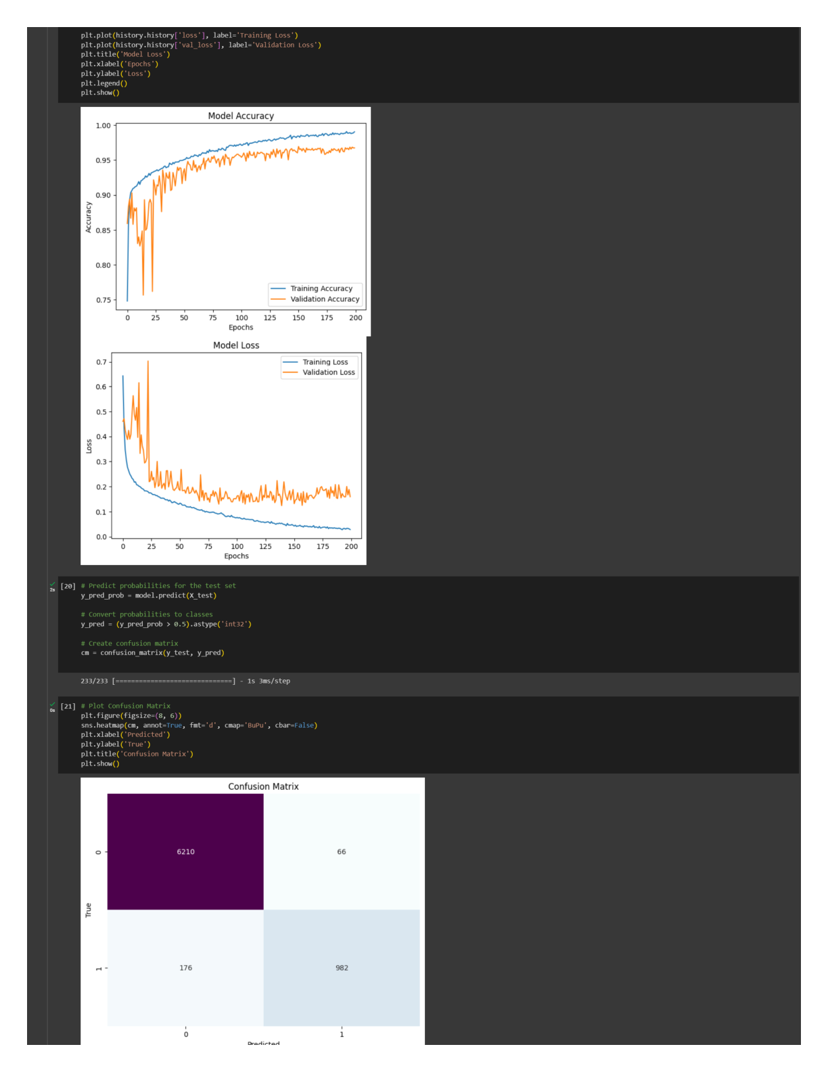
Figure A3. Training/validation accuracy and loss curves showing convergence and a modest train–validation gap.
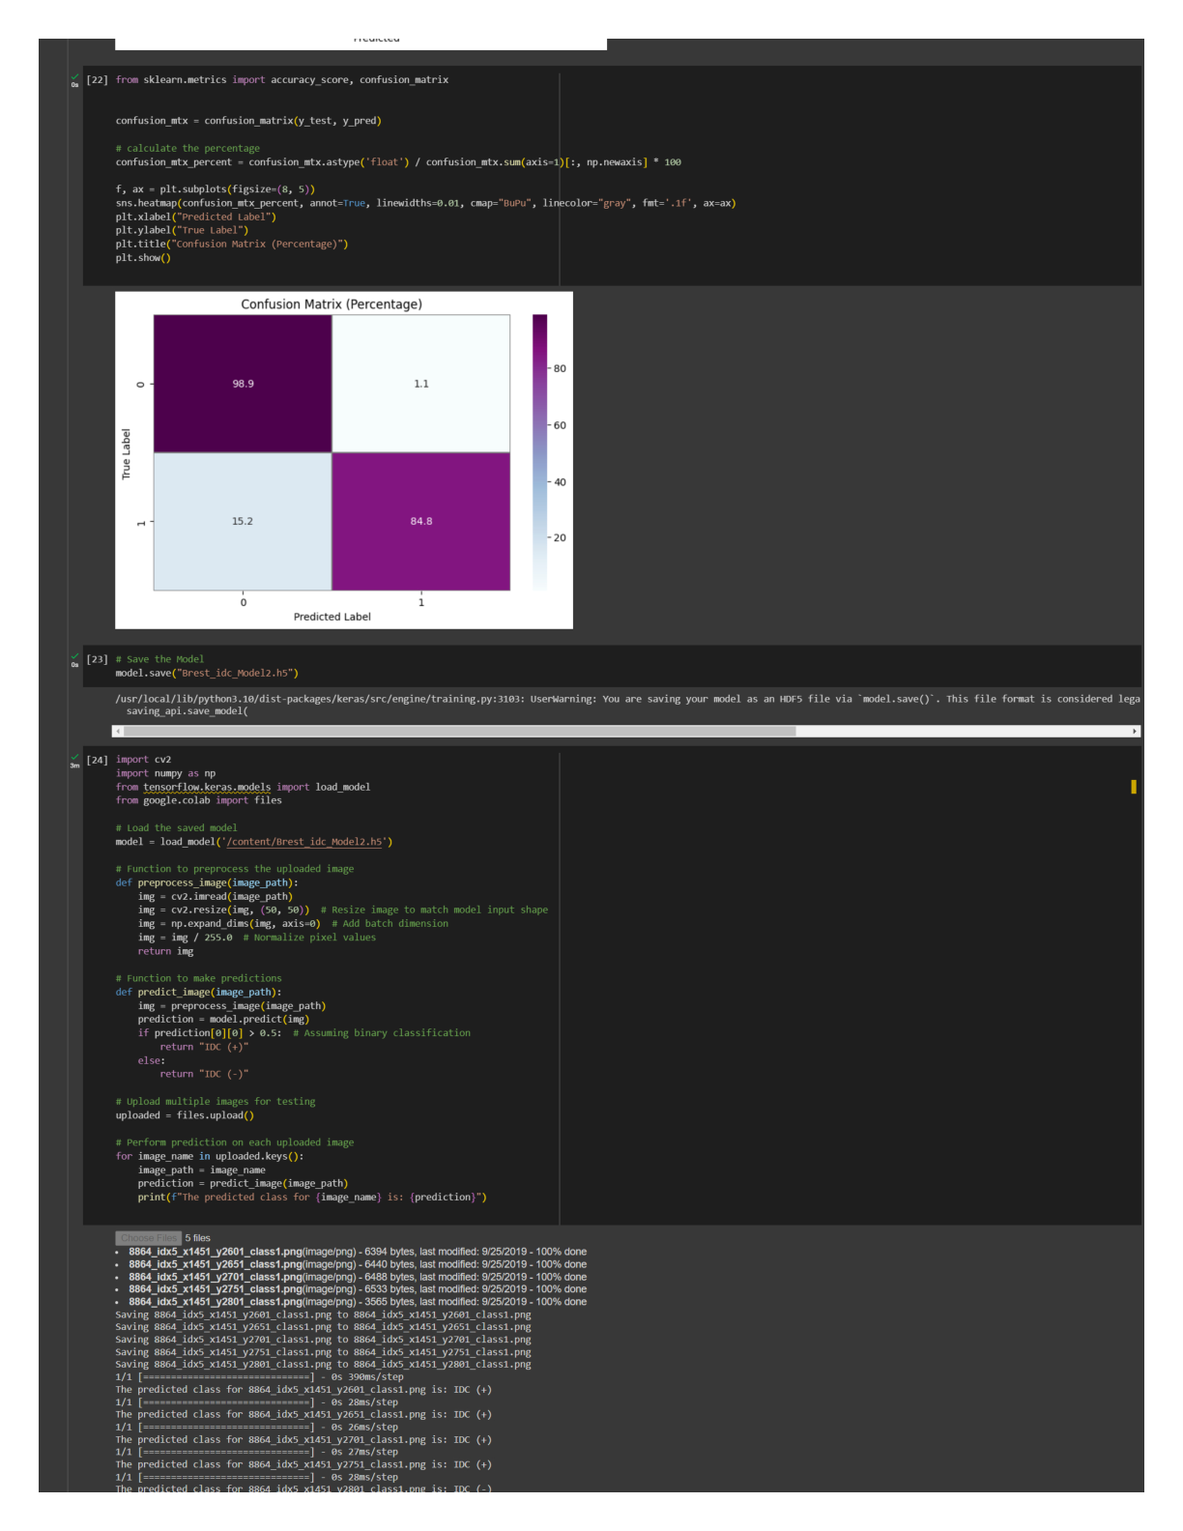
Figure A4. Confusion matrix (TN 6,210; FP 66; FN 176; TP 982) and percentage form (specificity 98.9%, sensitivity 84.8%).
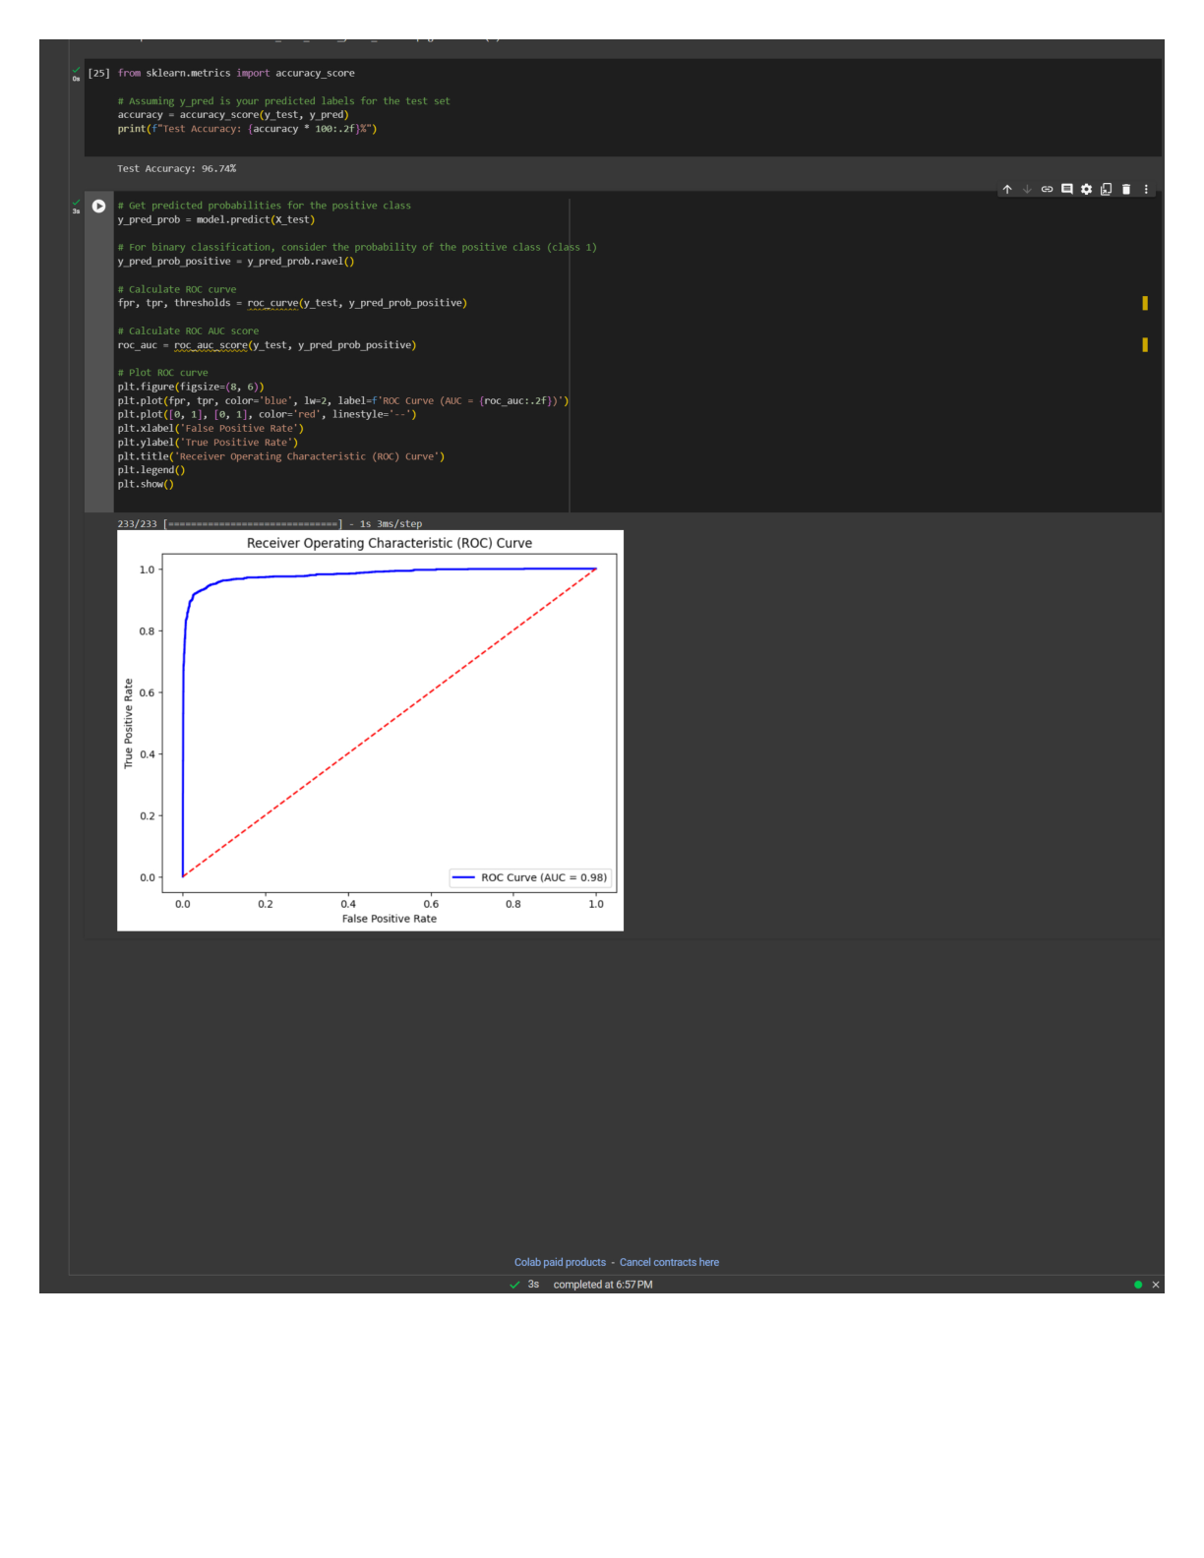
Figure A5. ROC curve for IDCNet (AUC = 0.98) and the single-image inference routine.

Appendix B – ResNet50 (transfer learning)
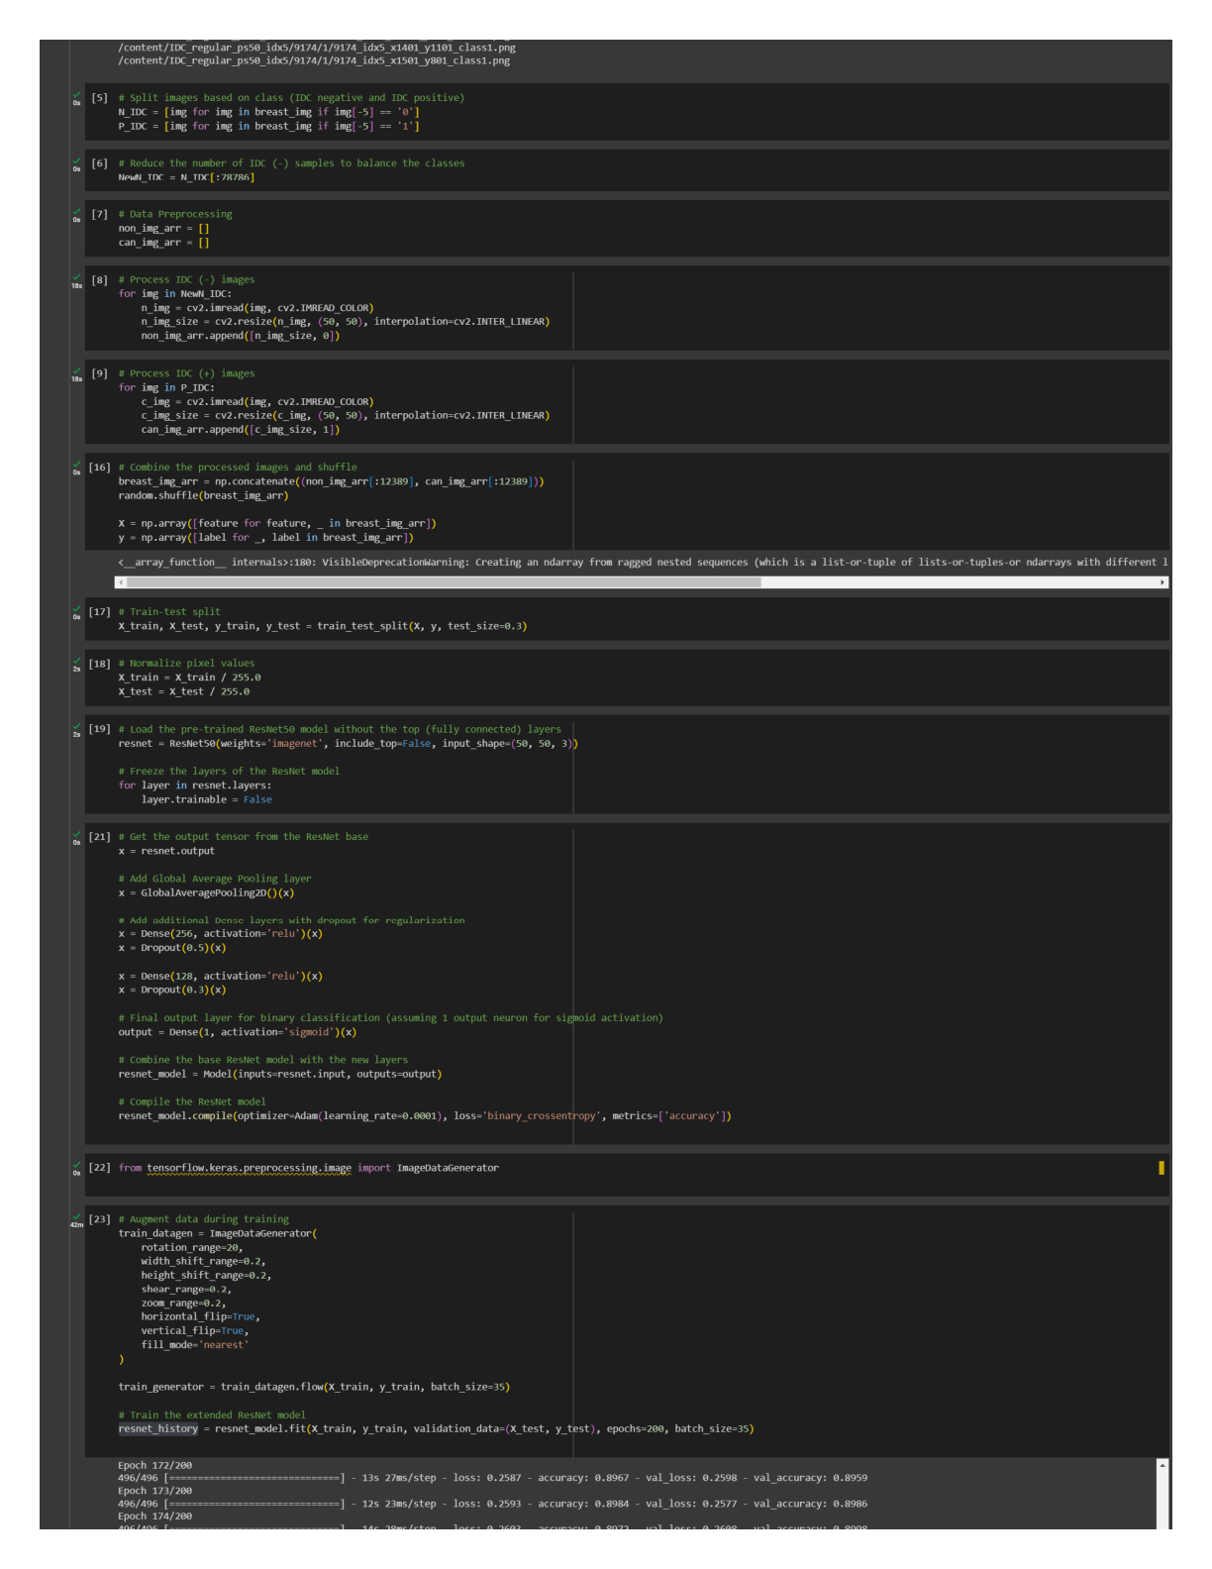
Figure B1. Frozen ResNet50 base with custom classification head; training configuration.
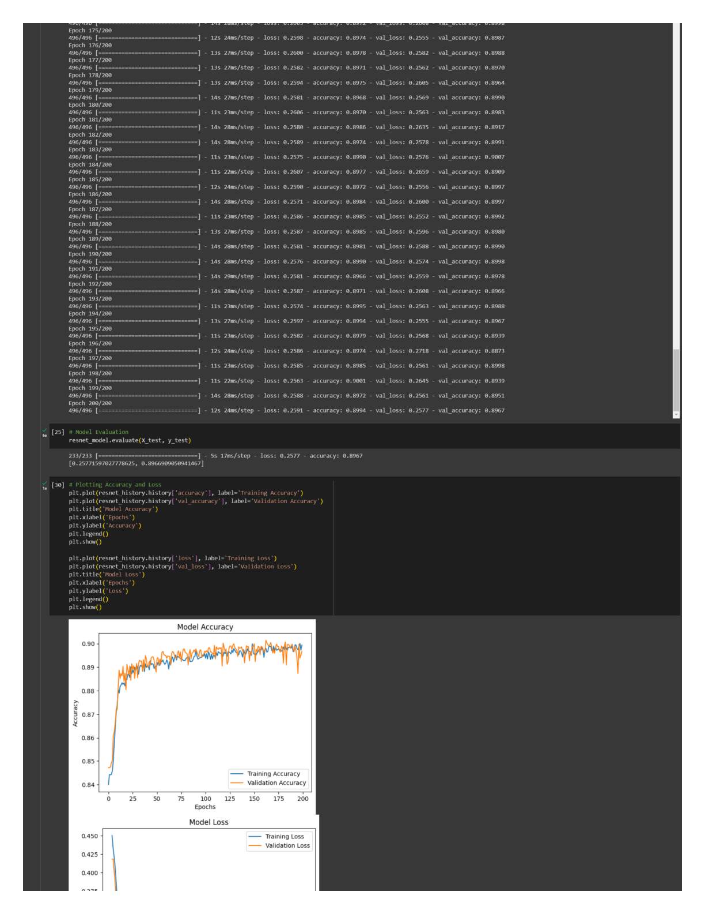
Figure B2. ResNet50 training log and accuracy/loss curves (test accuracy 89.67%).
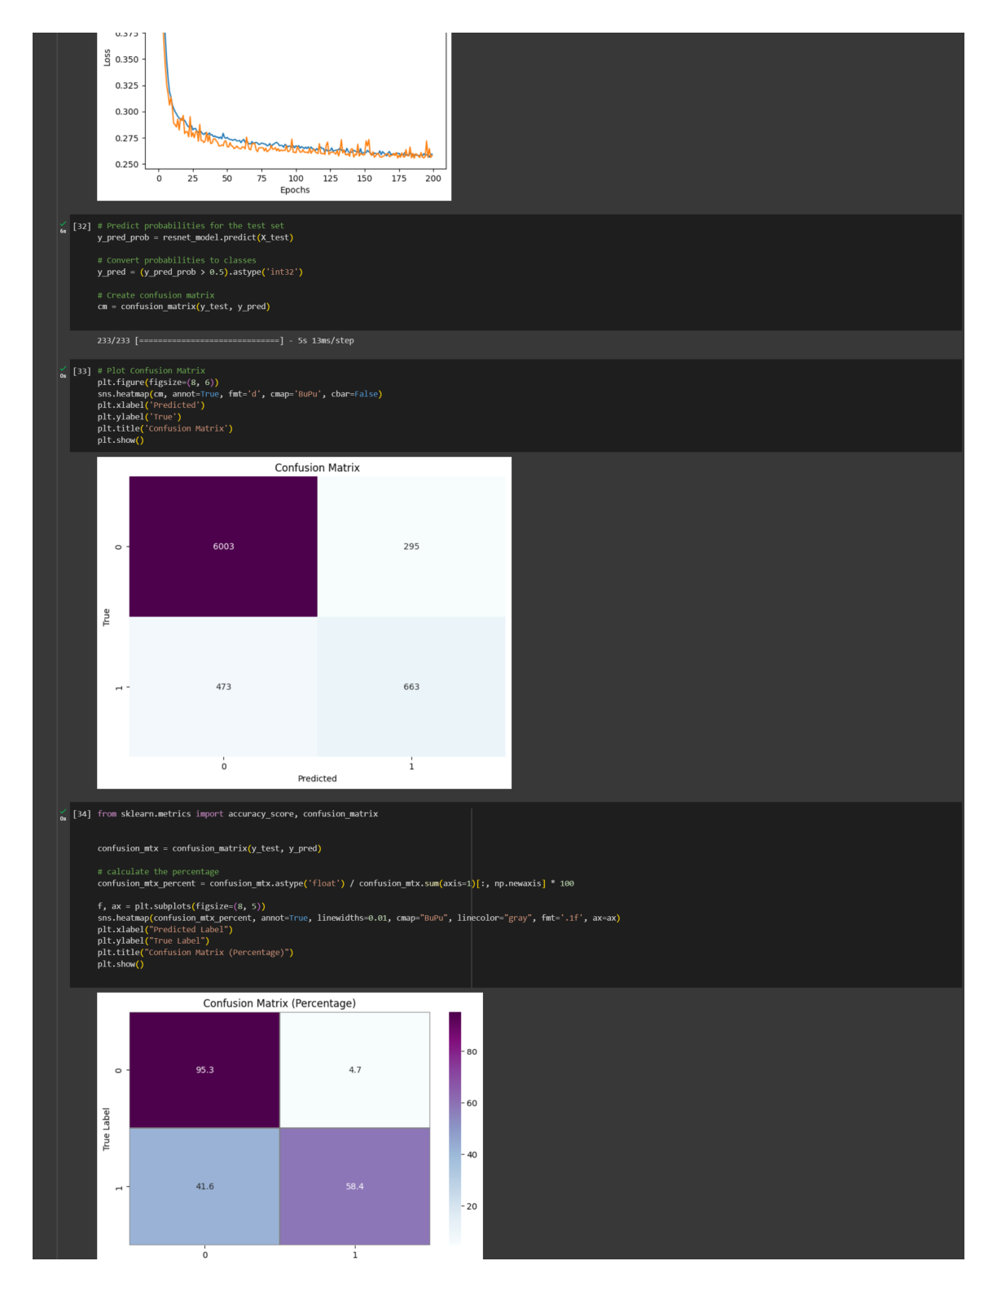
Figure B3. ResNet50 confusion matrix – note the low IDC-positive recall of 58.4% (473 false negatives).

Appendix C – VGG19 (transfer learning)
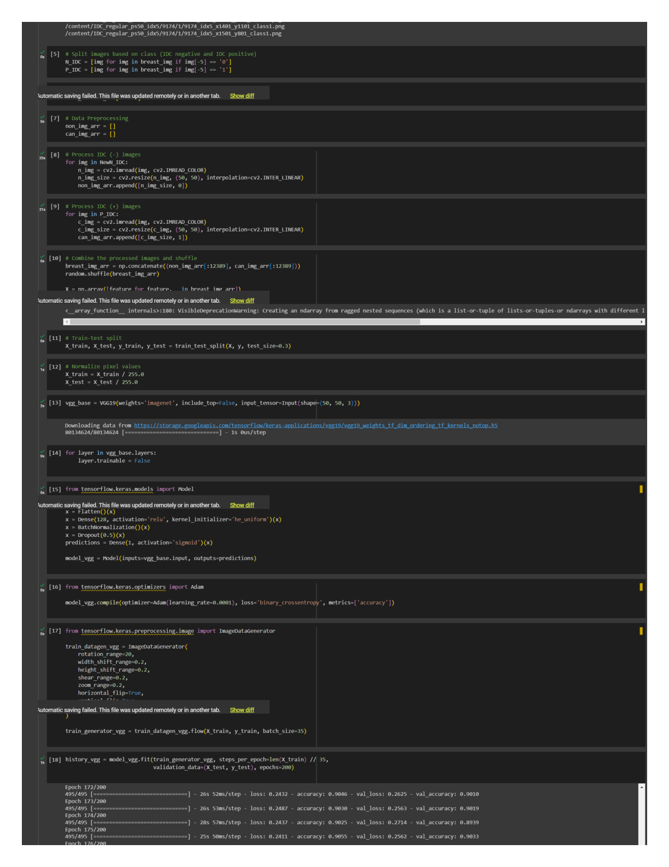
Figure C1. Frozen VGG19 base and classification head; training configuration.
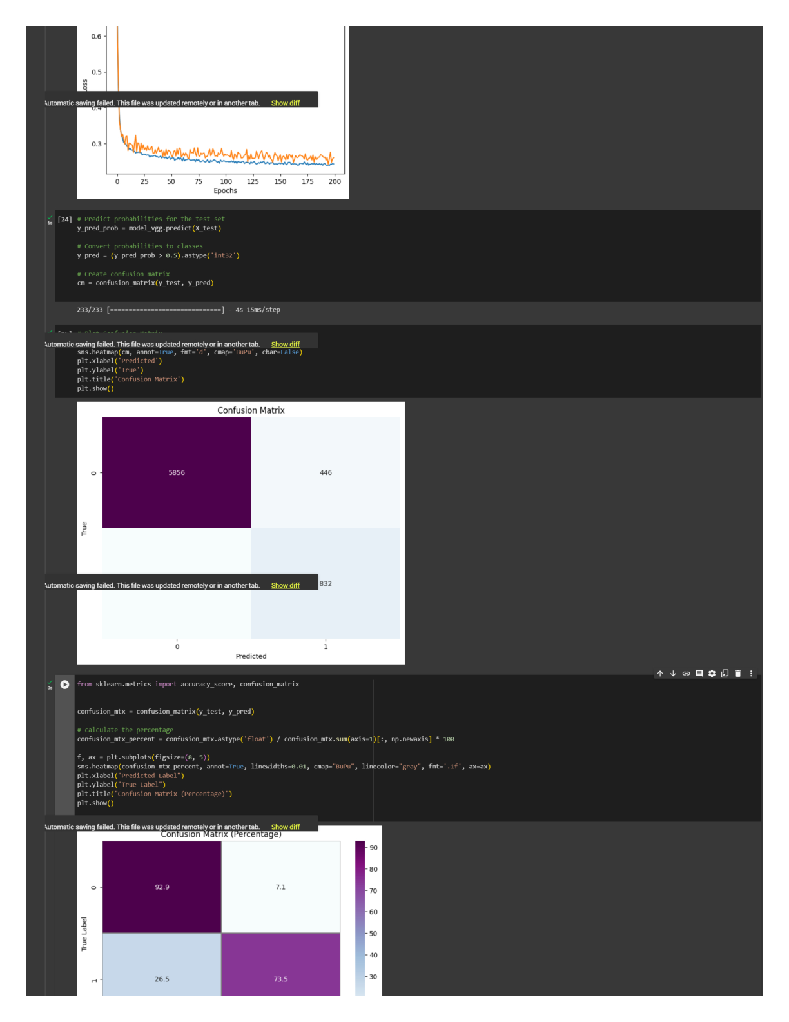
Figure C2. VGG19 accuracy/loss curves and confusion matrix (test accuracy 89.97%, sensitivity 73.5%).

Appendix D – EfficientNetB0 (transfer learning)
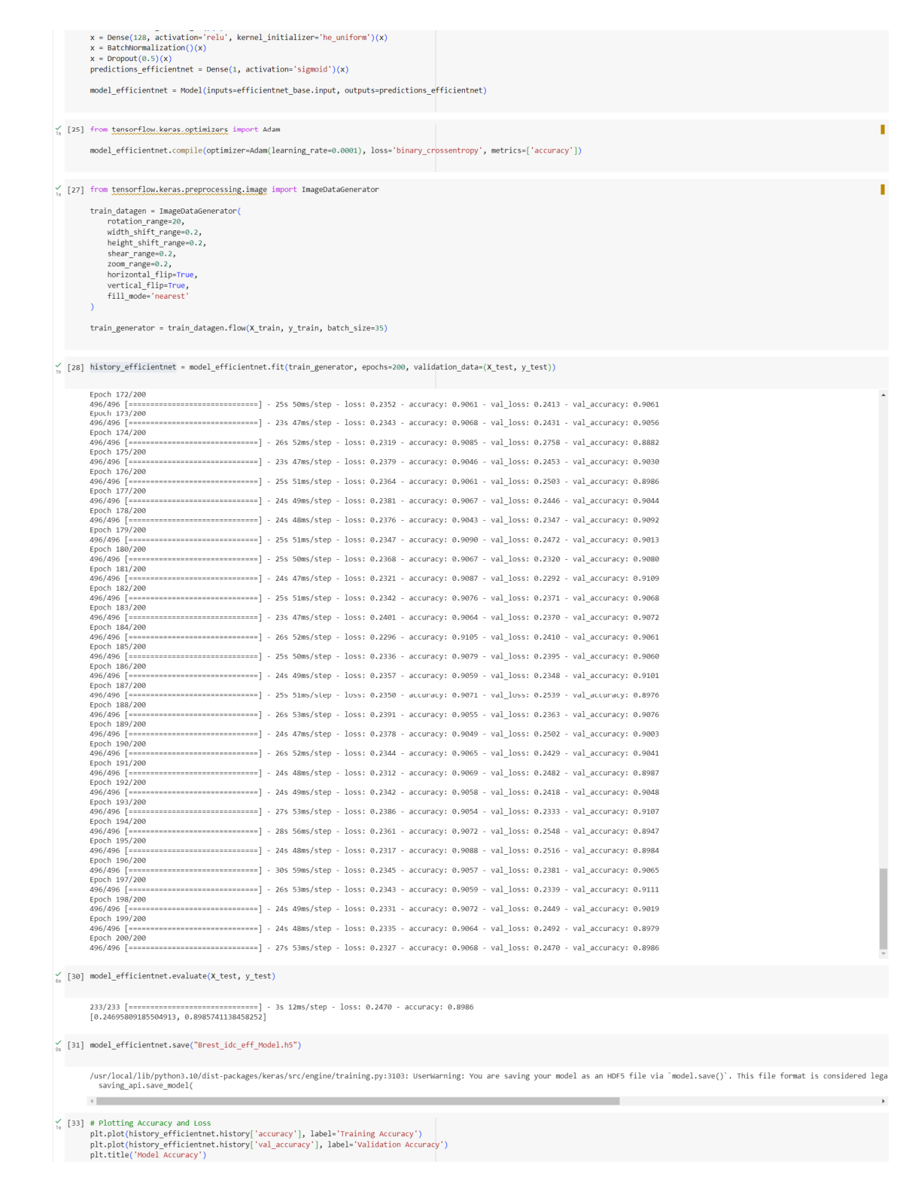
Figure D1. EfficientNetB0 setup, training log and accuracy/loss curves (test accuracy 89.86%).
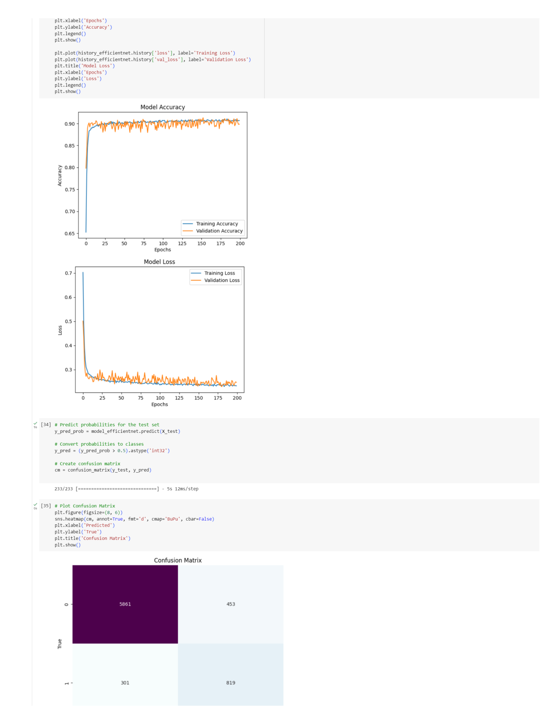
Figure D2. EfficientNetB0 confusion matrix (specificity 92.8%, sensitivity 73.1%).

Appendix E – Project timeline (indicative)
Phase | Jun–Jul | late Jul | Aug | early Sep | Sep
Data & pre-processing | ■■■
Model dev. & training | ■■■
Comparative evaluation | ■■ | ■
Formal validation (3-way) |  | ■■
Secure inference interface |  |  | ■■■
System & security testing |  |  | ■■ | ■
Documentation & packaging |  |  |  | ■■
Final report & demo |  |  | ■ | ■ | ■■
■ indicates active work during that period. Completed phases are shown to the left of the current interim point (July 2026).

